GREEK Holocausts. The monstrous crimes of the Germans during the first occupation of Greece
http://thehistoryofgreece.blogspot.com/p/blog-page_1206.html (in Greek)
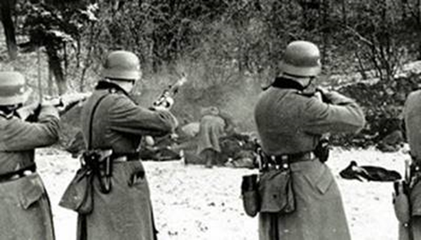
German Occupation Forces - Holocaust and Executions
October 17, 1941: The Germans execute 222 male residents aged 15 to 60. In the villages of Ano and Kato Kerdyllia in the province of Nigrita in the prefecture of Serres

October 23, 1941: The Germans executed 142 men, aged 16-69, in the village of Mesovouno, Kozani. They were executed "in groups and with automatic weapons".

June 3, 1941: The monstrous slaughter of Candano Chania (hereinafter full description)

September 28-29, 1941: The Bulgarian soldiers, with the tolerance of their German allies, execute at least 1500 people in Drama,

For example, in Doxatos alone, on September 29, Bulgarians executed at least 200 men aged 17 to 50 years.
October 3, 1943: The Holocaust of the Ioannina Ligiades (hereinafter full description)

April 22-25, 1944: Germans execute 150 residents and burn all their houses in the village of Mesovouno in Kozani Prefecture ..
March 1, 1943: The Germans execute 26 men at the Pavlou Mela Camp, in Thessaloniki.
July 25, 1943: The Germans execute 154 people in the village of Mousiotissa, Epirus.

August 1943: Germans execute 317 residents in Kommeno village of Arta and burn the village.

The victims included 74 children under 10 years of age.

September 4, 1943: Germans burned alive in the village of Ligades, Epirus 84 residents, 40 of whom were children under the age of 10

September 21, 1943: Germans kill 44 residents of Eleftherio village.

December 1943: The Germans execute in Kalavryta Achaia a total of 1104 men, 14 years of age or older (detailed description below).

By mid-December, 1,000 houses had been destroyed in Kalavryta. This particular German brutality has remained in history.
September 16, 1943: We had the Holocaust in the provinces of Viannos and Ierapetra, Crete. The Germans executed 451 people

November 1943: German troops kill 50 people in Argos.

November 1943: Germans kill 118 people in the village of Monodendri in Laconia. Of the 118 executed, 89 were Spartans. There were minor children and a woman among the victims.

December 3, 1943: The Germans execute 50 civilians in Patras.

December 5, 1943: Germans abduct 50 prisoners from Tripoli camp. They were hanged for "exemplification" at the Andritsas Argos train station.

December 7, 1943: Germans execute 40 hostages in prison in Gythio Laconia.

December 1943: The Germans execute a total of 119 people in the Laconia Prefecture. In the village of Andritsa, in the village of Passava and elsewhere.

January 3, 1944: The Germans execute 30 people in Patras.

January 8, 1944: Germans execute 12 men at Pavlos Mela camp in Thessaloniki.

January 22, 1944: The Germans execute 30 people in Patras.

January 1944: The Germans execute 456 hostages from the prisons of Tripoli.

February 23, 1944: The Germans execute 40 people in Katerini Pieria.

February 24, 1944: The Germans execute 204 people in Megalopolis, Arcadia (from the prisons of Tripoli).

March 31, 1944: Germans kill 65 hostages, in the village of Kranona

March-summer 1944: Germans kill

In March, 50 people in the village of Monodendri, Laconia.
244 people in Sparta in March-April.
In June 40 people in the area of ​​Agios Dimitrios Zoupaina, and in the Sustiani region (Laconia).
In summer 77 people in Panitsa, Skamnaki and Gythio.
1942-1944: A total of about 60,000 Jews from Greece are exterminated by the Germans.

Historian Hagen Fleischer estimates the total death toll is 56,385. (Source: Hagen Fleischer, Crown and Swastika)

April 5, 1944: Germans kill 280 residents in the village of Klisoura, Kastoria Prefecture. The vast majority of them were women and children. And they burn the village.

The Germans and the Bulgarian Komitas, led by the German commanders of Kastoria Raisel and Hildebrand and under the leadership of Bulgarian Kalchev, killed the inhabitants. With automatic weapons, choppers and bayonets. And they burned down their houses.

Slaughterer of the closet was Colonel Karl Schumers (Carl Summers), commander of the 7th Regiment of the 4th Armored Division of the SS.

April 24, 1944: Germans kill 318 people in the village of Katranitsa (Pyrgos) near Ptolemais.
The historic town at the foot of Vermio was completely destroyed by German barbarism.

April 1944: About 150 people are executed in Lamia and 64 in Larissa.

April 6, 1944: 50 people are executed at the Caesarea Shooting Gallery.

April 6, 1944: The Germans execute 50 people in Veria.

April 9, 1944: The Germans execute 50 people in Corinth.

April 10, 1944: Six civilians are executed in Lamia.

April 14, 1944: The Germans execute 120 people in Agrinio.

April 24, 1944: Conquerors set fire to Metsovo and kill 150 people.
April 25, 1944: At Karakolithos, 134 prisoners of the Livadia prison are executed.

April-June 1944: Germans burn houses and execute villagers in the villages of Levidi, Agios Petros and Vourvoura, Arcadia.

May 1, 1944: Germans execute 200 prisoners at the Haidari camp at the Caesarean shooting range.

May 3, 1944: Germans execute 57 prisoners from Hadjikosta Prison and 18 women from the Haidari camp.

May 4, 1944: The Germans execute 16 civil servants.

May 5, 1944: Germans execute 46 people in Chalkida.

May 10, 1944: The Germans execute 92 people at the Caesariani Shooting Range. Among them were 10 women.

May 11, 1944: Germans execute 100 people in Boeotia.

May 12, 1944: The Germans hang 24 prisoners from the Larissa camp at Doxaras.

May 16, 1944: The Germans execute 120 people from the Haidari camp.

May 23, 1944: The Germans execute the burning of Lake Argolida and execute 86 of its inhabitants.

May 28, 1944: The Germans execute 15 people in the village of Vathitopi, Corinth.

May 31, 1944: Germans kill 40 people in the village of Dasolofos of Farsala.

June 2, 1944: Germans execute 22 villagers in Kontomari village of Kidonia, Crete (details below)

June 6, 1944: Germans execute 101 people from the Pavlos Melas camp on the Thessaloniki-Kilkis road.

June 9, 1944: Germans arrest 1795 Greek Jews in Corfu. They were transferred to camps and killed, almost everyone.
June 10, 1944: Germans kill 229 people in the village of Distomo located in the western part of Boeotia Prefecture. Also, 67 civilians are killed in the surrounding villages. In the fields and on the roads (details below)

German barbarism set a new record. The killers murdered even pregnant women, the elderly, young children and babies.

For this inhumane crime, the German General Helmut Felmi who was in charge was sentenced to only 15 years in prison, of which he only served three.

June 26 - July 2, 1944: Germans in Kynouria, Arcadia and Mount Parnon, execute 202 people and arrest another 500.

July 1, 1944: Germans hanged 50 prisoners at the Haidari camp in Harvati, Attica.

July 2, 1944: The Germans execute 50 people in the Slaughterhouses of Thessaloniki.

July 6, 1944: Germans execute 200 people in Liosia Attica.

July 21, 1944: The Germans execute 50 hostages from the Haidari camp.

July 24, 1944: The Germans arrest about 1700 Dodecanese Jews. Then I sent them to camps where almost everyone was killed.

July 3 to 22, 1944: Germans execute 161 citizens in North Pindos. And they are destroying 4450 houses, 5500 huts, fences and barns. Indescribable looting and capture of 427 hostages.

July 31, 1944: Germans execute 59 people in Kalyvia Agrinio.

August 9, 1944: Germans execute 50 people north of Mandra Attica

August 13, 1944: The Germans block Kalamaria. It has 15 residents.

August 21, 1944. The Germans executed 30 men in the village of Damasta at the Keratidi site. Then they leveled the village.

September 2, 1944: The massacre in Chortiatis of Thessaloniki

September 8, 1944: 8 Jews are executed in Thessaloniki.

September 1944: German units invade Chortiatis village. The Subert Battalion scattered the terror. A total of 146 people were shot or killed. Of these, 109 were women. Most of their assassins burned alive in the village oven.

CRETE KONTOMARI
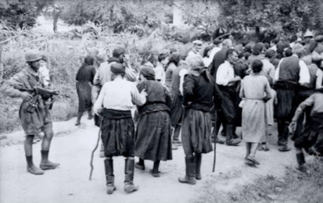

The first mass execution of civilians in Europe

In May 1941 the Battle of Crete was cruel and merciless and largely destructive to the Germans. Who had heavy losses. The Battle of Crete and the heavy casualties of the German paratroopers forced Geiringer and Hitler not to re-use the paratroopers in the aftermath of World War II.

Lieutenant Horst Trebes was the only officer who escaped without being hit. The dramatic hours he lived that day were to seal the fate of the neighboring village of Kontomari.
After the end of the battle and the final occupation of Crete, an excerpt from III Order, led by him, entered the village on the morning of June 3.
Scenes of the events were almost framed by a German photographer accompanying the paratroopers. And these photos were discovered in German archives forty years later by journalist Vassos Mathiopoulos.,

At noon on June 2, 1941, the paratroopers of Lieutenant Trebes, at the behest of General Stuent, as they said after the German war and defeat, invaded Kontomari, Chania. They arrested 25 male residents (aged 18 to 50) and executed them in the cold, without any further procedure.
Studend himself said he was ordered by Hermann Geering, who was also the head of German aviation.
The Germans then photographed the event in every detail. Lieutenant Vance Peter Wexler.
The photographic documents that follow are from that photograph. And they come from the German Federal Archives. As published in 1980 by Vassos Mathiopoulos in his book 'PICTURES OF OCCUPATION

1941 - Kandanos of Chania
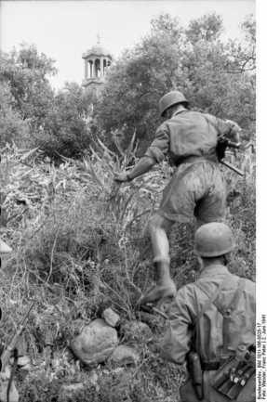
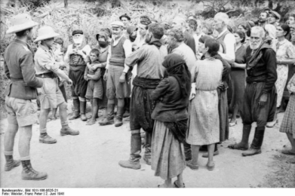
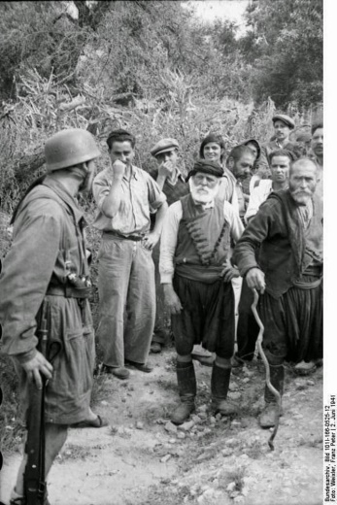
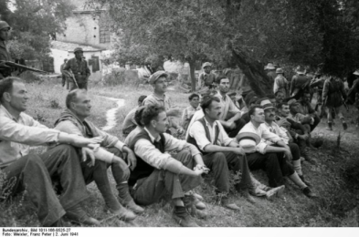
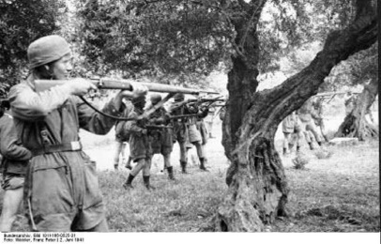
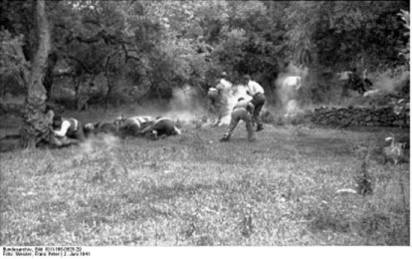
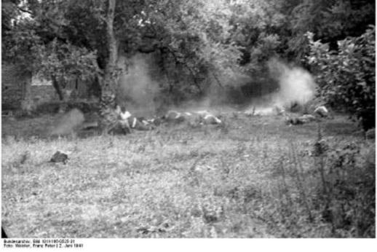
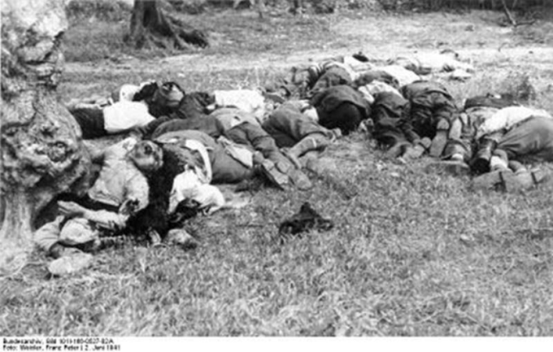

Crete has unfortunately witnessed many mass slaughter of civilians by the vengeful Germans.
And Kandanos, a hamlet in the prefecture of Chania, was to become one of the most gruesome monuments of German atrocity during World War II.

On June 2, 1941, the village was ruthlessly bombed and the next day the troops entered the community, burning and leveling all the houses.

Then the Germans gathered around 180 residents outside the Primary School and massively executed them.

From German mania neither houses nor animals escaped.
While they were so hateful, they also left written monuments of their atrocity. Not only by acknowledging their crime, but also by propagating it.

So in the following days, the Germans placed two inscription-signs on the Kandanu entrances. Written in German and Greek.
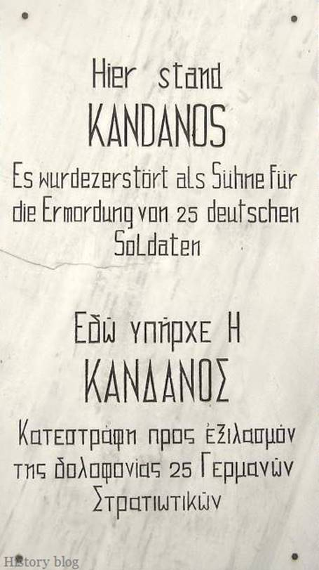

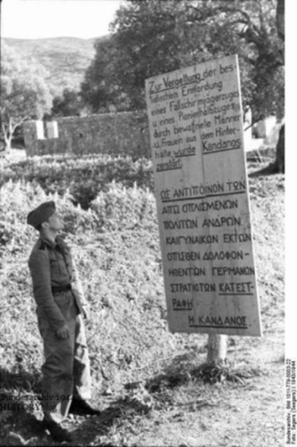
The first wrote:
"For the brutal murder of German paratroopers, alpinists and engineers by men, women, children and priests together.

And because they dared to resist the great Reich, the Kandan was completely destroyed on 3/6/41, so that POTE would not be rebuilt. "

The second wrote:

"Kandanos was destroyed, in retaliation against armed civilians, men and women, for the murdered German soldiers." The village was erased from the map ...

1943 - "Operation Kalavryta"
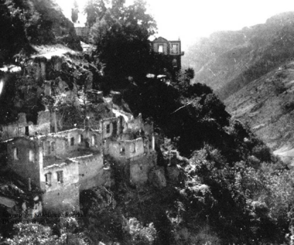
The area of ​​Kalavryta is a place with a long history and a revolutionary past against Turks. During the Occupation, it suffered enormous casualties, with mass executions of civilians and total destruction.
In the summer of 1943, executions, bombings and village destruction began:
July 1943 (July 29): Bombing of the villages of Lapata, Trechlo and Manesi. Among the 16 victims and young children.
August 1943 (August 31): Burning of the village of Ano Lousoi. Execution of 4 residents. Hanging in the square of Helmos Kalavryta the young Dinos Pavlopoulos.
November 1943 (November 29): Bombing of Vysoka village. 13 dead, injured and destruction of all houses .
The crimes of the German occupation troops culminated in December 1943. With an organized clearing operation in the Kalavryta area.
Known as "Operation Kalavrita" ("Unternehmen Kalawrita", December 5 to 15, 1943). One of Vermacht's toughest operatins, not only in Greece but also in Europe in general.
The German troops, which started from Tripoli, Aigio, Patras, followed a course, to he province of Kalavryta and ending in Kalavryta.
The German forces were led by Lieutenant Colonel Julius Wolfinger.
At the beginning they looted and set ablaze the monastery of Oblu, lying a short distance south of Patras.

On December 06, following a Wolfinger accident, was appointed in his post, the commander of the Aegean constitution, Ebersberger,
On December 07, hiking troops, villages scattered the fire and death to the villages they passed
In the village of Kato Vlasia, 3 men and 1 woman were killed. Three shepherds from Kalavryta and another citizen were also killed in the village of Kalano.

On December 08, they crossed the village of Manesi and the village of Saradi and killed one man.

On December 09, they reached the junction of Skepasto-Klitoria road.
In the chapel of Agia Anna, the whole male population of the village of Vysokas was then gathered. And after a brief speech, they were released. On the same day, they entered Kalavryta.

On December 10, five men were executed in the village of Syrbani (Priolithos).

The German forces from Aigio to Kalavryta, led by Lieutenant Colonel Ebersberger, entered Kalavryta with three hiking divisions.

On December 08, Ebersberger divided the army into two groups and in the morning, entered the village of Rogous. They completely burned down the village and executed 65 men and children.

Another group entered the same day, the village of Kerpini. Where they shot and executed 38 men and children,

They then burned down the village of Ano and Kato Zachlorou and killed 19 men.
They then reached the Monastery of the Big Cave and killed 16 people. Monks, visitors and others. 9 monks were also executed at the High Cross.

On December 09, they reached the village of Souvardo, where they set fire to and killed 5 men. The same at the village of Vrahni, where 6 men were also killed.

In the village of Kerpini a German platoon settled. And four men were killed there.
On December 09, the German forces, led by Ebersberger, entered the city of Kalavrita, where the forces from Patras had also arrived.

On December 13, 1943, they completed the operation.
They burnt down and completely destroyed the city of Kalavryta and plundered what was valuable. They executed the entire male population of the city. From 14 years old and up.
On December 14, they went near the Monastery of Agia Lavra.
They robbed the monastery, set it on fire and executed 6 men. Monks, visitors and others.
On the same day, the village of Vysoka was looted. There, after killing 3 men, they left for Patras.
They also passed through the Monastery of the Big Cave and burned it.
The German troops, moving from the city of Tripoli and led by Major Gnass, headed towards villages of Dimitsana and Lagadia of Arcadia district
On Saturday night, December 11, the Germans, executed 10 residents of the village of Mazeika at Magherou area
On December 14, they looted and burned most of the village of Mazeika and then left for Tripoli.
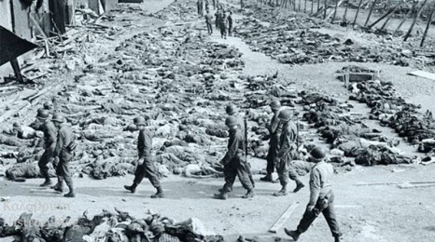
The confidential radiograph of 117 Jager Division (No. 1595/43) records the final report of Operation Kalavrita:
(1) Were completely destroyed, the villages :
Rogos, Kerpini, Kerpini Station, Ano Zachlorou, Kato Zachlorou, Souvardo, Vrahni, Kalavryta, Monasteries of the Big Cave and Agia Lavra, Agia Kiriaki, Avles, Vysoka, Fteri, Plataniotissa, Pirgaki, Valtsa, Melissia, Omblou monastery, Lapanagi, Mazi, Mazeika, Pagrati, Morohova, Derveni, Valtos, Planiterou and Kalivia.
(2) 696 Greeks were executed ... ".
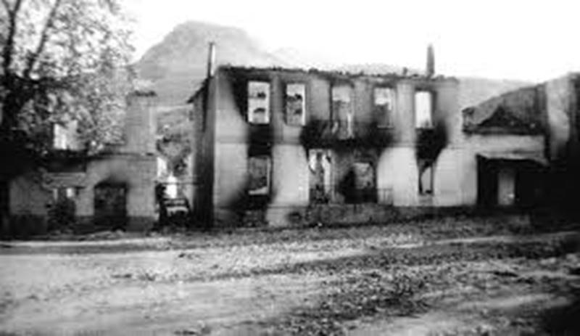
The Germans entered Kalavryta on December 09, 1943.
They then created a suffocating stranglehold around the city so that no one could escape.
The great anxiety of the inhabitants managed to appease her, deceiving them, the German Commander.
Who assured them, that there would be no harm and that their aim was to kill the rebels.
They first set fire to rebel homes.
On December 12, the Germans began preparing to leave the following day.
On the morning of December 13, Monday, before dawn, they rang the bells of the central church.
And then German officers and soldiers ordered all the inhabitants to gather in the Elementary School. After taking with them, a blanket and a day's food.
Separation of them, took place in the school building.
Female and children were locked in a school and men 14 years of age and over, were driven to a nearby place
The place was carefully selected. Because its amphitheatrically form would not allow anyone to escape.
At the same time the toothed rail was going downhill, full with from the looting by Germans. From houses, shops and warehouses. From where, they grabbed every valuable one.
They also seized the money and stocks of Banks and Public Services. Rreviously he Directors,werte forced to hand over them
The motto of the execution was given by the hotel "Alexander the Great" with a green and then a red flare.
The machine guns then killed all the inhabitants of Kalavryta. Then came the the fatal shot , that completed the crime.
Only 13 people were rescued.
In elementary school, female children lived through moments of anxiety and trepidation as the flames, set the school building on fire.
Breaking doors and windows they finally managed to escape, by running away from the burning homes.
Then they went mad, searching for their own persons.
Then the women went to the place where the Germans had led the men. And they found themselves in front of the most horrifying and inhumane spectacle. Men, fathers, sons and brothers, dead and flooded in blood.
The youth, the creative forces of the city, their fortunes, and their time, disappeared at 2:34 pm on December 13, 1943. As indicated by the indicators of the church's stopped clock.
The women then began to dig with their own nails, to dig graves in the frozen land of December. To bury their dead.
With their blankets, they carried the dead to the cemetery. And they buried others, on the hill where they were executed. A tragic process that lasted for days.
Then came their attempt to survive in the rubble. Which for many years, housed the families
The women from Kalavryta, heroic figures, struggling under difficult conditions, and managed to raise their children and rebuild the city through the ruins.

Kommeno of Arta district, August 16, 1943
In 1942 and especially in 1943 the liberation resistance struggle intensified and the German front began to collapse.
In the face of this situation, the Germans are implementing, among other things, the Hitlerian principle of "solidarity of responsibility".
Executing one hundred civilians for each killed German
At the same time, because they were unable to clash with the rebels and exterminate them, they turn against cities and villages and commit atrocious crimes.
Their purpose was, by the retaliation, to disperse the resistance organizations . And to sow terror in the cities and villages. So as to erase, any resistance fire.

In August 1943, ELAS guerrillas came to Kommeno and demand food. The locals are not responding, as they were already supplying the EDES (another resistance organization), which was controlling the area. They even called for the reinforcement of the EDES forces to prosecute the rebels.
On August 12, the Germans, after information they had, rushed to Kommeno to inquire whether there were actually guerrillas in the area.

At dawn on August 16, 400 men, from the 12th company of the 98th German Constitution, based in the town of Philippiada (a small town), parked outside Kommeno.

The task of the 12th company was to eliminate the guerrillas operating in the area and to disappear the village that supported them and was supplied them , food and other necessities.

Commander of the Constitution, was Colonel Joseph Zalminger, a young commander, with a lot of decorations.
A self-made man who liked to play a role in turning 98th into a constitution for Hitler.
Salminger had a typical speech, to the men of the 12th Ward,
He told them: "German soldiers have been killed. It is time for tough measures against the guerrillas. Tomorrow morning we will eradicate, a haunt of them. "
After midnight, most residents in Kommeno began to slowly go home to sleep, tired of the preparations for the feast of Virgin Mary, from the feast and the drink. Without suspicion of anything about what was going to happen.

At about the same time, a convoy of 22 cars and a military jeep set off from the valley near the town of Philippiada, carrying most of the men of military company. Around 100 soldiers.

At 5.00 in the morning they stopped outside the village and the cook served to the soldiers, breakfast and coffee .
Then the Commandant of the 12th company, Lieutenant Reser, a former Hitler;s youth member and now about 25 years old, gathered them and gave them his orders.
A phrase that had remained in the men's minds for years: "We will go into the village and leave nothing upright" had said.
Using the church's bell tower (built in 1855) as an observatory, they were divided into executive quotes. Taking the final instructions.
On the early morning 16th of August, flares of different colors, began to intersect. At the same time, there were explosions of mortars, placed at three topical points in the village.
Immediately, the shots began. And the firearms and the machine guns that didn't stop for a moment gave the impression of a tough battle.
They then invaded all the houses. And whole families that were sleeping and were unable to react, they fell dead from the bullets and grenade launchers.

Old people, handicapped, even blind, were killed on the spot.

Girls threatened with weapons were drawn to the utter humiliation of their personality. And were repeatedly raped by young Germans who, after satisfying their beast instincts, cut the girls' breasts and slaughtered them as if they were animals.

These anthropomorphic beasts employed a satanic tactic of killing young children.

After rubbing a piece of cotton with gasoline, they placed it in the mouths of infants still asleep on their bed. And after they had done so, they enjoyed their "fireworks", laughing sadistically.
Of a pregnant woman, having opened her belly, they took the fetus she would bring to the world in a few days. And placed it in her arms. That's how the woman found herself. Dead with open bowels and her unborn child, deformed, dead in her hands.
Other children were executed, with a pistol on their head. While others, despite their innocence and weeping, were nailed with their swords.
In Theodore Mallou's house, was the wedding of Alexandra's daughter, with Theocharis Karinos from the village of Pachikalamos, a village near Kommeno. Everyone was lost.
They burned them and killed them. Thirty to thirty-five people.
Of the 12 members of Host Theodore Mallou's family, only two were saved that morning. Alexander and Maria, who had just went, a few minutes ago, to care for the animals on the field.
The Germans did not respect and did not respect nothing and no one. They also killed the bride Alexandra, and Theocharis' groom.
Those who succeded getting out of their houses, were running to the fields or hiding in the deep ditches.
Only the river was left for many as salvation.
Crowds of people were running there. Others were thrown into his waters to cross and be saved. Others were hung from the boats and trembled as they struggled to escape the nightmare.
And almost everyone on board the boat of Spyros Vlachopanos drowned. Almost twenty people.
And the lamentation and the screams of drowning mingled with the noise of the fire and the weapons that were destroying the village of Kommeno.
The Germans did not respect, even the church of Our Lady. After they had evacuateδ to the gate of the holy step, they threw the iconostasis and the sacred vessels into the floor of the temple.
That morning, August 16, Pope Lambros went to church with him the gospel, the incense, and the vestments. He used the day before to have a wedding.
Pope Lambros was captured by the Germans and after being brutally tortured, he was dragged to the door of the church and executed with a bullet.
He was also the first victim of Kommenu massacre. With the Gospel, perforated by a sphere in a corner. And with his pages watered, by the blood of this honest clergyman.
The other priest of the village was found killed , full of blood, with his eyes exited
With a special powder thrown to the floor and a pistol, they burned most of the village's houses. Taking before, every valuable there was inside.
The scene in Kommeno after the massacre was appalling. Everywhere the killed were charred. While the atmosphere smelled of burnt flesh.
The rotting had already begun with many human offal, spilled into the ground.
Many human members were scattered here and there. While dogs led by blood, had begun to eat pieces of meat from various bodies.
On the afternoon of August 16, Dimitris Apostolou, a young Kommeniot, returned to his village and home.
The German troops had left after their "operation" wich lasted 7 hours.
In the charred remains of houses, the beams were still burning. And the killed, were starting to swell from the heat.
A woman's belly had been torn and a chicken had begun to drag its intestines along the way. Shortly after seeing this, Apostle fainted. Shortly after seeing this, Apostle fainted.
A total of 317 people were victims of the village of Kommeno that day, at the massacre. Probably the most horrible crime committed in Greece during the German Occupation.

The Holocaust of Viannu on September 14, 1943
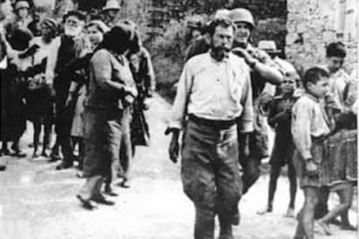

Destroy the province of Viannu. Immediately perform, without any procedure, males over 16 years of age. Also all the arrested in the open air, regardless of gender or age. "
General Friedrich Wilhelm Muller, city of Heraklion, September 1943.

From September 14 to September 16, 1943, 401 people were killed in the provinces of Viannos and Ierapetra. The second largest Holocaust in the country. By order of the slaughterer Friedrich Wilhelm Miller.
Only from Amira, my village, killed 117 of our fellow villagers.
Among them was my grandfather Aristomenis, his three brothers, Paul, John and Matthew and their father Nikolaos.
Five people in total from the same house!
Two more, brothers of my grandfather's, who were set in the execution firing squad, survived.
From the wider family, we count dozens of dead.
The following is an excerpt from the report of the Central Committee for the Establishment of Crimes in Crete. The committee of, N. Kazantzakis, I. Kakridis, I. Kalitsounaki and K. Koutoulakis.
Visiting our province nearly two years after the Holocaust:
"The Commission will never forget the devastating spectacle it saw when it reached the village Amiran. She found about 300 women dressed in black.

With lament for their children and fate. The next morning a religious memorial service was held at the place of execution. Only a little can show the taken photos , the suffering and lament of the women.
And to our great regret we find that the distribution of false and unfounded data continues by the German Governments! And what, the German state has not said, in order not to assume responsibility for crimes against humanity committed by the Third Reich in Greece:
The official response of the German democratic state to the legendary Argyris Sfountouris is indicative. According to which the Holocaust of Distomo was:
"Inevitable event in the context of war operations". And therefore "the families of the victims are not entitled to compensation!"
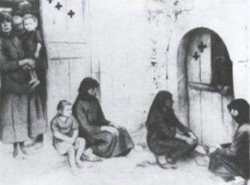
There was no home in the whole province without victim
Calvary, of those who lived
The cross of the martyr was heavier for those who survived. Hunger and misery followed the bloodshed.

Germany, was provocatively absent from the charge of their drama .

The Germans tried to cover up their crime and asked the then high priest and after Archbishop of Crete Eugenio Psalidakis to sign a false statement.

And he, with unparalleled courage, replied:
"Shoot me, but I'm not signing a false statement, because I saw with my eyes, eviscerated women

The massacres, danced upon their victims and made fun, with the suffering women, shouting Nazi slogans.

Characteristics of the Exhibition: Kazantzakis, Kakridis, Kalitsounaki:

"Of the murderers Germans, others went to Krevata village and others stayed in the village of Amira.

Those who stayed went to a yard near the site of the murder of the world. And they started eating and having fun.

And to mock mourning women . Imitating the cries of their despair. "Holy Mary, Holy Mary!".

But they didn't stop there. They continued their work in Krevata village:

"After the execution, the executive extracts of Vachos, Amiras and Kefalovrysos were collected in the village of Kevvata.
And with the phonograph music they started having fun at G. Zoakis' house.

And then drunk, they danced on the corpses of the executed people shouting. "Heil Hitler" and "Long Live Germany" (in Greek). "

But they continued their horrible work for two more days.

Summary of the Holocaust of the villages of Viannos and Western Ierapetra:

401 dead, ten villages became ashes and 950 houses were completely destroyed.

Detail: Before the houses were blown up, they looted by every valuable inside. And they loaded them on the animals. And neither the animals were returned.
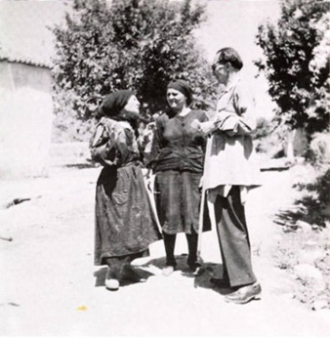
Author Nikos Kazantzakis talks to relatives of German victims during his tour of the island as a member of the Central Committee for the Detection of German Cruelty in Crete (Kazantzakis Publications Archive)
Report of the "Central Committee for the Determination of German Crimes in Crete"
"Emmanouil Simvoulakis was arrested while trying to escape, holding his three-year-old daughter in his arms. Later was led with others for group execution. Holding his little daughter in his arms, .

He then escaped the bullets, fell to the ground and pretended to be dead. But because his little girl was crying, a German soldier shot her close and killed her. The unhappy father remained motionless for many hours, with the blood and scattered mind of his child on his face. Until the Germans left. After eating and having fun"

"However, the biggest disaster occurred at this time, in the province of Viannu. In blood and in village destruction.

In January 1943 the Germans arrested as hostages, daughters of notable Greeks. 6 from Vachos village, 9 from Amiras village, 4 from Kefalovrisi village, 2 from Krevatas village, 10 from Ag. Basil etc.

And they locked them for a month in the prison of Agia. So as to force residents to surrender their weapons.

Mount Dictis, in the summer of 1943, was the seat of Kent's guerrilla body. Crete. Headed by Emmanuel Banduvas. Emmanuel Banduvas was then ordered by the English to cause episodes in Vianno.
So as the German army to be employed there. This is how two German soldiers were killed at the village of Symi in Viannos.

Germans sent then a company to Symi, which was ambushed by the rebels outside the village on September 12, 1943. This German company was then dissolved. With casualties, 30 dead and 12 prisoners.

At the same time, the guerrillas released and 12 Greek hostages. Who were arrested by the Germans from the villages of Kefalovrisi and Pefko. To execute them, at the place where two German soldiers had been killed by rebels, .

Among the hostages was Kefalovrissi's pastor Matheos Gialadakis.

The next day, the German administration sent strong troops from Heraklion and Ierapetra. Which enclosed the whole province of Viannu.

The surrounding villages knew that the enemy's defeat in Symi would be paid for. But what the forfeit would be, they couldn't imagine it.
However, immediately after the battle of Symi, all the men left the villages.

But the Germans implemented their usual policy. Arriving at Agios Vasilios village on September 13, they behaved with great humility.

And they assured the women that they do not consider the villagers responsible for what the guerrillas do. And that nothing will happen. It was enough to host them. That's what happened.

They also announced that those found in their homes would not suffer any punishment. But if they were absent, they would punish their wives and children. And they would burn their houses. And they would chase them as guerrillas.
The nearby villages that were notified immediately took courage.
And they decided to take care of the Germans when they would go to their villages. Many of the men who were away, were persuaded by their wives and returned to their villages.

The following day, September 14, at the Feast of the Ascension of the Holy Cross, became one of the most terrible catastrophes that Crete experienced throughout the German occupation.

The Germans invaded the villages, Vianno, Amira, Vacho, Kefalovrisi, Kevvata, Agia Basil, Pefko, Kato Symi, Godia, Myrtos, Mournies, Riza, Malles etc.
And they killed first, those who were found in the streets. Men, women and children. And in villages after gathering the men, in groups, they killed them.
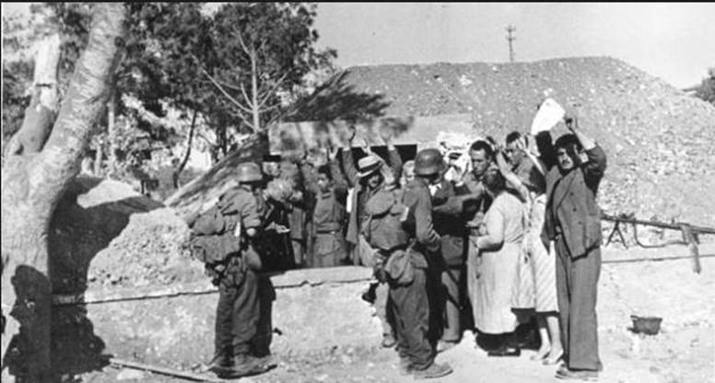
As the Germans entered the village of Amira, the residents, on the recommendation of the mayor, greeted them at the entrance of the village with wine, raki and meze.

But the Germans, having already surrounded the whole area, arrested all the men, about 100.

And they executed them, without any procedure. Just down the public road. Their execution in sections lasted from 10 in the morning until 4 in the afternoon.

In the meantime they also killed those who could not move. Elderly and disabled, found in their homes.

Among them, we mention the paralyzed 80-year-old Dimitrios Mathioudakis, who was killed on his bed. Also the very old, Emmanouil Grimbolakis. Paralyzed by birth.

Matthaios Sygellakis, a 20-year-old, was also killed by spear, in his home.

Many were also killed in their fields or on the street.

Of those executed in group, 6 were rescued. Of whom 3 died from their wounds after a few days.

The village had a total of 117 dead that day. Only one family, named Verikokakis, mourns its 17 members.

The Raptaki family mourns 12 blood relatives (brothers, uncles and first cousins).

The Eliakis family, 10 grooms, 10 brothers and cousins.

Father Sykellakis and his 4 sons were killed by the Sygellakis family. Aristomenus, Paul, John, and Matthew.

Catherine Mikrogiannakis lost her husband George, her father Nikos Chalkiadakis, her brother George, her father-in-law Emmanuel and her brother John.

Matthaios Christakis or Syllas, was executed at the same time with his two sons and his 4 husbants of his daughters. M. Vardiatakakis, N. Kondylakis, M. Sabrovalakis and S. Kousoulakis.

Of these, the dead, the two sons and the first of the grooms, pretending the dead, were rescued. Who was left disabled.

Also, three other brothers were killed at the same time. Matthaios Georgios, Myron Vassilakakis and G. Anastasakis. The latter with his son and the two husbants of his daughters

Of the killer Germans, some went to Krevata village and others to Amiran. And after they had settled in a courtyard, near the place of execution they began to eat and have fun.
Making fun with the desperate women, imitating the cries of despair: '" Holy Mary, My Holy Mary !"

When they later left, the women dared to approach the place of execution. The faces of the dead were distorted as the Germans shot at their head. That is why they were often recognized, only by their clothes

"My father's and my brother's minds, were poured down," one woman told us.

Another: As "pieces" I took my son , and I went to bury him."

And their burial became very difficult, because the few men in the village who escaped were still in the mountains.

And the cemetery was 20 minutes up the embankment. That's why some of the killed remained without burial and were devoured by the dogs. Like Nikos Christakis and Emmanouil Consoleakis.

Those who were buried in the village had the same fate. About 40. Because the land there, was very hard and their burial by the women, was done perfunctory

For a long time women carried soil from around, to supplement the burial of their own.

And in the morning they were finding the members of their dead, scattered around by the dogs . As the dogs, dug at night the graves .
The same thing happened to those who were murdered in the surrounding estates.
Also the same for those who were murdered inside their homes. For example, Aristotle Syngelakis, who was found devoured by dogs and pigs.
Also, Matthaios Mantouvakis and Markos Raptakis.
The village was not looted that day, nor was it destroyed like the other villages. The Germans, however, took care to "repair" their omission.
So in June 1944, a squad of 500 men settled a short distance from the village. And they robbed it, like all the surrounding villages. And they forced the widows even to deprivethe milk from their orphans . And to give it to the German barbarians.
They stripped the houses and their furniture (tables, seats, etc.) and gave receipts. And they assured that they would return. Of course, when they left, they took all with them.
The Commission will never forget the enormous spectacle it saw when it reached the village of Amira, to see that was described above. At the execution site, they found about 300 women with their children gathered. To lament and faint.

The next morning, a memorial service was held at the place of execution. Where the tragedy can only faintly be understood, by the photos taken.

On the same day, September 14, 1943, the Germans, with other extracts and in the other villages of the province of Vianos, murdered as many men, they found them in the villages and surrounding areas.
Their casualties are less than those of the village of Amira, because these villages were smaller, and because the inhabitants were notified of what happened to Amira, and left their villages.
So in the village of VACHOS all the arrested men, were executed. A total of 23. Out of which 3 survived.

Among those killed was community leader Heraklis Pournikakis. Who had previously refused to sign a letter at the request of some residents who were afraid. To appease the Germans. "I cannot dishonour my signature," he said.
In the execution, as the three survivors testify, he showed remarkable courage. He embraced the for execution Greeks, saying, "So, the freedom is coming"

The village houses were looted but not destroyed.

KAFALOVRISI VILLAGE.
Here too vainly inhabitants had attempted to soften the fury of the Germans. They wellcome them, with the head of the community ahead. And they were offered raki and delicacies.

The Germans, however, arrested all the men found there and, after expelling the female children, executed them near the school. A total of 33. Of these, 3 survived.

They also killed with a bayonet , Emmanuel Kontakin, on his bed

The priest and teacher of the village Manolis Gialadakis lost on this day, his brother, his son, his son-in-law, and his brother . The Germans, after looting the village, left.

In the village KREVVATA 21 young were killed as a group. The elderly and the sick were killed in their homes. And two outside the village.

Among those executed was the priest of Vachos village, Leonidas Pnevmatikakis. He was in the village of Krevata, in the Church service, for the Feast of the of the rise of Holy Cross.

The priest appeared before the Germans raising the Cross. And exorcising them to have compassion for the inhabitants. In response the Germans shot him. And while wounded, he was dragging to a house they re-shot him and killed him.

After the execution, were collected in the village of Krevata, the executive troops of the villages of Vachos, Amiras and Kefalovrissos . And under the sounds of a phonograph they began to have fun, on the roof of the house of George Zoakis.

And drunk, were dancing on the bodies of the executed Greeks, shouting "Heil Hitler" and "Long live Germany" (in Greek).
Not even for the village of SAINT VASILIOS they had mercy . Despite all the promises they made the day before.
Thus, on the afternoon of September 14, 31 men were killed (24 of them in a group).
Among them, Germans killed with an ax in his bed, 65-year-old retired squadron Georgios Vasilikakis. And with a bayonet, 17-year-old Stylian Barbagadakis.
When Apostle Vardakis was attacked the moment they shot him, they opened their body from untillhis neck to his abdomen with a sword.
Emmanouil Counoulakis, while trying to escape, was arrested, holding his three-year-old daughter in his arms, . And he was involved, in a group execution, holding his baby girl.

After escaping the bullets he fell down pretending to be dead. But because the toddler was crying, a German soldier shot him close and killed him. The unhappy father remained motionless for hours, with the blood and scattered mind of his child on his face.
Until the Germans, after eating and having fun, left.
Among those executed was Corfu professor Efstathios Mastoras.
Among the German executive team, was a soldier with a particular hatred against the village.
Ths soldier in January 1943, while drunk, he found a woman in the village of Saint Basil on the street, and tried to rape her.
She then fled to a house, where after he killed Sakis Monokandilos from Kalymnos. And because the persecuted woman had escaped, he went into another house, expelled the owner and raped his wife Doxania Vardakis
Then he went out into the streets and started shooting. The residents did not dare to arrest him and confined themselves to reporting to his superior authorities.
The soldier after trial in the village of Vianno was sentenced to 5 years 'imprisonment after the end of the war (!)
So this soldier who now came as a member of the executive team, wanted that all those who had complained to him be revenged. Among other things, community president Angelis Hatzakis.

VILLAGE PEFKOS
The Germans, while going to the village Symi on September 12, looted Pefkos village, killing 5 men.

And on September 14, they executed 14 more in the village of Pefkos and the surrounding areas. Then they set fire to the village. And they also destroyed the farmhouses around the village.

Among the dead are community president Charilaos Tsagarakis, the teacher Aristotle Miliarakis, who was found with his head cut off. And the , George Prestakis, Emmanouil Somarakis and Nikolaos Somarakis, who were killed with bayonet .
The village, which had 563 inhabitants before the war, now numbers only 485. Of the 78 missing, those who did not fire died from hardships.
VILLAGE KATO SIMI.
On September 14, 23 Greeks were executed by Germans
Among them was a woman. Her name Maria Panakakis, 85. She was burned by Germans inside her home (while her +husband was shot).
These 23 killed by the Germans Greeks, were arrested around the village. Because the village was a desert. Apart from the aforementioned Panakakis and the 80 year old paralyzed Stylianos Mylonakis, who could not be removed. And he was executed inside his house.
The same day, 10 more Greeks were executed by the Germans. From the villages, Ano Viannos, Sykologos and Kalami. Among them was a deaf 65-year-old woman. The Apraxia Athousaki.

For the villages located east of the village of Viannos, in the prefecture of Lasithi (in the province of Ierapetra), Germans "served" them, the following day (September 15th). So the Germans killed:
In the village of Ghohia 37 people in total.
The system was the same. The men who had left the village earlier returned. Because the Germans had done no violent act. Then the Germans arrested them and executed them along with those in the village.

17 of them were executed as a group with a machine gun in the Kartsana area. The rest were executed by the Germans in the village and the surrounding fields.

Among those executed were the elderly, Emmanouil Lenakis (80 years), Nikos Pigiakis (80 years), George Daskalakis (75 years), George. Metaxakis (75 years old). Also Germans killed Emmanuel Komitakis with his 13 year old son Charalambos.
They also burned in his bed with gasoline, the disabled, George Bekrakis, 40, father of four minor children.
Maria Archontikakis mourns her husband Georgios, her father Emmanuel Dimitrianakis, her two brothers Ioannis and Michael and her stepfather Emmanouil Archontikakis.
Because the whole region was declared "dead", with traffic being banned, the dead were left homeless for two months, and the dogs had eaten them.
In the village of MYRTOS
18 Greeks were killed by the Germans and 8 other on the outskirts. Emmanuel Daskalakis, 82, and Catherine Kanaki, 70, were among them.
They also killed community president Michalis Andreopoulos and vice president Ioannis Frantzikinakis.
In order the inhabitants not to be considered, being part of the guerrillas, the president of the community and the priest had previously appeared to the Germans and stated that all the men remained in his village.
The Germans pretended that they trusted them, and asked the president to prepare them, food. However, when they finished eating, they occupied the village exits and they ordered to be removed from the village, the families from Ierapetra . Which families were there, because of the destruction of their homes.
Because the locals, were afraid after this order, they began to leave with those of Ierapetra. The Germans repeated the statement that they had nothing to fear if they stayed there. And after a while they executed them
In the village of Mournies
They were shot in the Kale place 17. From the villages of RIZA and PARSAS, where the guerrillas had raised the Greek flag.
Another 4 were also executed from the village of Mournies.
They also burned inside her house, Maria I. Andreopouli, 70.
Charalampos Papadopoulis was among those arrested. Where as to be saved, he gave to the Germans, what precious he had with him (rings etc). The German soldier, as soon as he received them, killed him.

The village of MALES
Had in total, 17 executed Greeks
The same day they were executed
In the village of RIZA, 18.
In the village of CHRISTOS, 7.
In the village MYTHOS, 14.
Where they also killed 80-year-old Elder Nikos Christakis, who was shot in the seat where he was sitting.
And in the village of Parsas they killed, 7.
For the executions that took place at the same time, on the outskirts, on the farms, etc., of Viannos province, we mention the following characteristics:
Germansarrested three men who were hiding in the gorge of the village of Kalami. Kostas Koundourakis, Nikos Zoakis and Emmanouil Pyrovolakis with his young son George.
The Germans then killed the men with a bayonet, and the child was injured by a grenade thrown and is still hospitalized.
Christos Vervalakis from the village of Kefalovrisi and his three children, had taken refuge in the Argoulida farm They killed him, along with his three minor children. 12 year old Styliano, 8 year old Maria and 6 year old Evangelia.
Seeing the Germans approaching (September 14th), the father left the farm and was hidden in a bush. From where he could watch what was happening. The Germans, after entering the farmhouse, found many backpacks of food belonging to the fleeing locals. They then suspected that they were intended for the rebels.
They arrested the abandoned children and began torturing them to make revelations. They drove them out, they carved their cheeks and their feet with their bayonets and pierced their footing.

And because the children had nothing to say, they removed their teeth with a bayonet. And finally they slaughtered them with the bayonet. Then they spread them on the wall of the estate, with their heads hung.

The same day (September 14th), the Germans arrested 8 people at Ligia area. Among them, Charalambos Papadimitropoulos. Who showed to the Germans, a note from a German soldier who wrote that Papadimitropoulos had been treated him for injuries during a two-day battle in Symi.

However, the Germans also executed Papadimitropoulos along with others. Two survivors were injured and they were saved, pretending to be dead.

Among those killed on the outskirts was Maria. Daughter of the aforementioned Charilaos Papadimitropoulos. Catherine Papadimitropoulou. Pregnant 8 months.
As well Catherine Miliaraki.
Also Helen, the wife of George Mari and her 7 year old son Michael.
On the outskirts where the Germans found the following women from Kato Symi were massacred:
Kalliopi Sygellakis, daughter of Zacharenia Rhinaki.
The mother-in-law of the last Maria Rhinaki and Maria G. Metaxakis.
And in the arms of his mother, was killed George. A nine-year-old kid, son of Zacharenia Rhinakis,.

The Germans also killed the 80-year-old from the village of Godia. Charilaos Xanthaki and Kalliopi N. Papadaki.

This was the tragedy of the villages of Viannos.
Probably the first part of it. Because the Germans were not satisfied, only with the killing of so many hundreds of victims. The villages also had to be thoroughly destroyed.
So after about 15 days a notice was issued that defined the entire area as a dead zone. Apart from the villages of Viannos, Vachos, Amiros and Agios Vasileios.
To the residents was given, a period of some days, to leave. However, the lack of means of transport has allowed residents to save only a small portion of their property.
Elsewhere, even this opportunity was not given. As in Kato Symi.
The inhabitants of eastern Viannos (villages of Mirtos, Gdohia etc), were ordered to gather in Ierapetra. And the residents of West Viannu were ordered to leave the province.
Then, after the villages were plundered, they were burned and blown up with dynamite. Along with churches and schools.
The following villages were completely destroyed:
Sikologos with 80 houses.
Kato Symi village, with 245 houses. The village was burned on on September 13 and was thoroughly demolished on October 9. Among the 245 houses are those of Loutraki, a winter residence for the residents of Symi.

Pefkos village, with 80 houses. It was burned on September 14, and they were demolished after about a month.
Kefalovrysi village with 80 houses.
Krevatas village, with 70 houses.
Gdohia village, with 100 houses. Not a single house was left standing.
Mournies village with 110 houses.
Myrtos village with 110 houses. Not a single house was left standing.
Riza village with 30 houses. They burned only one settlement of the village.
Kalami village with 40 houses. Only 1/3 of the houses were destroyed. Because, with the mediation of the then Commander-in-Chief of Crete, a new order was issued by the German Headquarters which abolished the previous one.
Partial was the destruction of the village of Epano Symi.
Also, the seaports of the districts of KERATOKAMPOS and ARVI, were destroyed.
The Germans had looted the products stored there and destroyed their homes and warehouses.
It is very typical that the Germans later sought to conceal their crimes in Vianno.
And they pressed the arriving Archimandrite Evangelos Psalidakis, a spokesman for the Metropolitan of Crete, to sign a statement that no violations of international law had occurred during the events of Viannos.
But the archimandrite, who was not cared by their threats, pulled out the cross from his chest, put it on the German officer's table and cried. Shoot me, but I'm not signing a false statement. Because I saw eith my eyes, eviscerated women.
The Calvary of the survivors of Viannos
The cross of the martyr was heavier for those who survived. Hunger and misery followed the bloodshed.
The Holocaust in the Devilish Monodendri
In 1943 the German conquerors exterminated the village of Monodendri, the flower of Laconian society.
Among the 118 corpses fired by the Germans machine guns, were entire families, minor children and a woman.
The 89 were Spartans, the rest from the surrounding area.
It is the occupation period, where holocausts take on massive dimensions.
The executions by units and tens gave the place to hundreds, even thousands, of murders!
As in the unthinkable for human mind humanity of Kalavryta a little later.

In Laconia, Arcadia and Messinia since the autumn of 1943 bloody terrorism had taken the form of a genuine massacre.
A great form of self-sacrifice and patriotism is the execution of Dr. Christos Karvounis at Monodendri, who was born in Arachova and studied in Germany. Together with 117 other patriots. From the Germans on 26-11-1943.
An excellent doctor, educated in Germany, who gave his patients life out of his life ... he thought in the uncontrollable tragedy of the massacre that among the 118 were underage children, four brothers from one family (Tzivanopoulos) and three from two others (Alemagidis). and Kechaya).

He begged the Germans not to kill the minor children ... All they could do was answer him, he was to save himself ... He insulted them ... He, however, chose the glorious death.
The Germans ruthlessly beat him, so that no one stood up anymore. "

Among the executed were:
The director of the National Bank of Sparta (A. Zervobekakos), the lawyers (Fikioris, Salmas, Alemagidis, Theofilis), the professors (Chios, Papadakos, Koutroumanos), the journalists (Tiriirou), the fathers and sons (Tzivanopoulos, Alemangidis, Andritsakies, Papastathis, Stavrakos ...), professionals, people of labor, shepherds, but also a woman (Vassiliki Marinaki). Every home and dead ...
All those who would staff the local community after the liberation

1943. In addition to Monodendri, we had three other sites of martyrdom in Laconia at the end of 1943.
In the village of Andritsa 45 were executed on 6 December
In the village of Passava 49 on 7 and 8 December
In the village of Megalopoli 25 were executed on 10 December.

1944. The list of those executed by the Germans from the beginning of 1944 to the summer of 1944, is more longer
Indicatively:
Monodendri Village 50 killed in March.
City of Sparta in April and March 244 killed.
In the villages of Agios Dimitrios, Zoupena and Soustiani, 40 killed in June.
In the villages of Panitsa, Skamnaki and Gythio, 77 killed in summer ...

Karakolothos Village April 25, 1944

On April 25, 1944, the Germans executed 134 civilians in retaliation. Of these, 110 were hostages from Livadia prisons.

In addition to the detainees in the Livadia prisons there are victims from the village of Distomo and the village of Kyriaki. As well as 39 from the city of Lamia
The civilians killed were:
From Livadia
Loukas Tampakis, Evangelos Tampakis 27, Georgios Karamanis, Efstathios Pantelopoulos,
Efstathios Agrafiotis, Georgios Koutsonikas 27, Dimitrios Theodosopoulos 23, Michael Arounis 17, Christos Manias 24, Athanasios Magas, Nikolaos Floros 20, Georgios Botsis,
Philippos Dokos 25, Konstantinos Makropoulos, Matthaios Moraitis, Michael Fororiaris 22, Anastasios Vallas, Sotirios Pasha 30, Charalambos Mitsou 35, Konstantinos Patis 24,
Constantine Koutsonikos 24, Leonardos Kountouriotis 55, George Bechlivanopoulos 18, George Mantazis 24, Alexander Xylomeletis 27, Efthimios Demos, Athanasios Kountouris, Constantine Makris, Theodoros Simeonides 42, Anastasios Sakellaropoulos 24, Basil Giakoumis, Lazarus Anthopoulos, Panagiotis Athanaklidis, Evangelos Chalkidakis, Konstantinos Kastanidis, George Zachariou, George Fontopoulos, Dimitrios Sparos, Evangelos Angelakakis, George Matsas 22, Grigorios Konstantinou, Thrasivoulos Vamvas, Spyros Pallas, Kosmas Triandis 40, George Sigalas, Leonidas Skliros, Dimitrios Mantilaras, Athanasios Apostolidis, Konstantinos Tsaousanis, Ioannis Dedes, Nikolaos Melissarakos, Lukas Vasiliou, Petros Stamatakis, Spyros Sideris, Michael Zontikas, George Zygogiannis, Dimitrios Kapoulas 43, Konstantinos Papaioannou 29, Christos Zaridis 33, George Tsiamatis , Charalambos Kalyvas 18, Ioannis Kalyvas 29, Simos Ch. Lambrou.
From Distomo
Dimitrios Sfountouris 28, Othon Karagiannis 24, Efstathios Sideris 23, Ioannis Gavrilis 24.

From the village Kyriaki
Theodoros Lazarou 24, Georgios Skondras 27, Nikolaos A. Tsouras 22, Nikolaos G. Tsouras 22, Loukas Koutsikos 23, Konstantinos Benekos 21, Charalambos Kollias 26, Konstantinos Venasou 22, Loukas 26

From Lamia
Vassilios Katzalis 34, George Skouras 32, Evangelos Staikos, Konstantinos Trahanas, Efstathios and Georgios Mourounis, Floros Anastasiou, Demosthenes Taxiarchis, Evangelos
Ziros, Georgios Kontropoulos, Georgios Efthimiopoulos, Vassilios Lekkas 31, Georgios Kouzas, Dimitrios Koufokostas 19, Grigoris Pardalis 23, Konstantinos Gouzos 26,
Basil Manigiotis Elias Skounterakos, Efstathios Strangylakos 38 Dimitrios Kapetanakis 22 Efstathios Dardis, Alexander Karetsos 30 Nikolaos Baronos 32 Anthony Kakos 33 Efthimios Belakis 39 John Belakis 22 Efstathios Giannakopoulos 35 Apostle KONTOGIORGOU Theodore Gkoltsos, George Tselios, Christos Stoforos,
Komnas Komnas, Evangelos Kourkoutas 27, Loukas Tzifas, Loukas Thanasakos 28, Apostolos Kourogiannis, Apostolos Kouroubalis.

The document, Nos. 368 and 287/1945 of the Hellenic War Crimes Bureau find that those responsible for the crime are:

Colonel Heisel, Lieutenant Werner, Lieutenant Maar and Sergeant Jans.
These same Germans are also responsible for the complete destruction of the village of Ypsilanti in BΙotia on August 10, 1944.

DISTOMO, June 10, 1944
The Germans in Greece, knowing that their days were little and would soon be forced to leave, had begun months ago to implement a plan for massively exterminate the civilian population.

Already at the end of 1942 there was an order by General Caitel to pave the way for mass crimes against the Greek people:

Commanders of Major Caitel, (by Hitler's command)
December 6, 1942 »
"The enemy has thrown into the war the fanatical fighters who have been trained by the communists and do not stop in front of any act of violence. What is being played here is more than a survival struggle.
This conflict has nothing to do with military honor or the decisions of the Geneva Conventions (!!!)
If this fight against the gangs in the East and in the Balkans is not carried out with the cruelest means, the forces we have may not be enough in the near future to impose this scourge.

That is why the units are authorized and mandated in this race to take any measures, without restriction or even for women and children, if these measures are necessary for success.

Humanitarian reservations of any kind constitute a crime against the German nation ... "

So the Germans embarked on an unprecedented mass execution operation. And the word "brutality", would be very poor to describe.

From mid-1943 to mid-1944, was incredible what they did.
Slaughter of 106 prisoners in Kurnovo.
Execution of 317 residents in Kommeno Arta.
Massacre of 700 female children in Viano, Crete.
Burning of Kalavryta and death of more than 1,000 residents.
Execution of 50 residents of Haidari in retaliation for the execution of the Minister of Labor, with the name, Kalyvas.
Massacre in the village of Katranitsa (Pyrgos) in Western Macedonia, killing 640 civilians and burning all homes,
Execution of 233 children and women in Kleisoura, Kastoria.
Burning of the village of Mesovouno (three times) and execution of 150 civilians etc.
And the report only refers to the civilian population, as the mass executions of captive guerrillas, were on the agenda.

However, June 10, 1944, the massacre of Distomo, remained in history as the day when one of the most atrocious crimes of the Germans in Greece and in the whole world was committed.
A day when atrocity and barbarism exceeded any limit.

On the morning of that day, a German convoy launched from Livadia to Arachova as part of the clearing operations they were doing throughout Central Greece.
Passing through Distomo, they plundered it and headed for Stira, a village where they thought they would surprise ELAS guerrillas.
But the surprise was for the Germans, who were heavily attacked by a guerrilla force, with the result that they withdrewed, with significant casualties.
The Germans, believing that the inhabitantsof Distomo's had alerted guerrillas and that they were responsible for their surprise, returned to Distomo and committed an unprecedented atrocity.
They executed more than 200 residents, 20 of whom were infants, 45 children and 42 adults.
In addition, they killed dozens of civilians in route to Distomo. In the end they killed up to the animals and set fire to a significant part of the village.
But they were not satisfied with the death of so many the civilians. The anthropomorphic beasts
Had slaughtered even the dead bodies of their victims.
The horror was incredible. Many babies were strangled.
Helpless old men were shot again and again.
They executed pupils in the school classroom.
Even the pregnant women, after they killed them , they gut their belly, they took out the embryos, and cut them in pieces
The streets of Distomo had been reddened by the blood of its inhabitants and on the trees on the road leading to the village, they hung dozens of dead bodies.
George Wehrly, the Swiss, who was in charge of the International Red Cross mission arrived in Distomo.
His testimony is revealing:

"... The exact number of victims is difficult to determine because many victims are still scattered in the fields and on the streets ...
Everywhere I found large bloodstains, scrambled for women's hair, children's shoes, torn clothes and covers.
The soldiers, according to eyewitnesses, ruthlessly chased people from room to room, and no had not any sad, for children, for women or for old men.
Only those the escaped or hads been hidden, they were saved from the slaughter. (...)
Children up to five years old, were found with their larynx cut or strangled.
Many young women were raped and subsequently they cutted their belly. "
The news of the massacre spread immediately around the world, prompting reactions and feelings of disgust.
Even the occupying prime minister, I. Rallis, protested to the German military administration.
The German administration tried to justify the fact that there were hidden guerrillas inside the Distomo and could not prevent the deaths of some innocents.
In the newspapers of 9 July 1944 the German authorities announced that: "the death of a number of women and children has been unavoidable ..."
The commander of the massacre, F. Lautenbach, claimed that he was attacked with heavy weapons from the direction of Distomo. Which was quickly refuted.
In a survey conducted by the German administration, Lautenbach said:
"... having in mind the dead and the injured of my men, I consciously made the decision to follow the spirit, not the letter of the retaliatory orders.
I knew that my orders could be interpreted as a formal breach of command, but I thought they would be approved ex post on the basis of military and humanitarian criteria. "
Lautenbach also argued that the insurgents could not be attacked without help from locals. "
… Their presence in the countryside in agricultural work was intended to deceive our forces for the ambush. Proving their pre-planned cooperation with the gangs ...
My measures intendeded also, to prevent as much as possible. further losses that one could expect ".

Of course, no one was convicted, after the court cited "military necessity" and that the Laoutenbach's attitude was justified because of the "sense of responsibility" he had towards his men.

The finding stated:
"In a case of synchronizing civilians with gangs, so visible as that of Distomo, the Commandant felt that he had to function exemplarily, so that the occupation authorities could prove with due rigor that they knew how to deal, with even the most obscene and fraudulent form of supposed 'war'
After the end of World War II, one of the officials responsible for the massacre, Hans Zabel, fled to Paris.
However, he was arrested and handed over to the Greek authorities. During his detention, the West German government requested him for questioning. He never returned.

The tactics of the criminals are steady. They are trying in every way to avoid the consequences for their crimes
A few months after the massacre at Distomo, the loser Germans, left Greece.

It is a rule, that when the conqueror turns against the civilian population, he is now weak. And applies this method because he is the only one left way, to cast the morale of the rebels.
And it is almost law-abiding, that when the conqueror reaches this point, his defeat is very close.
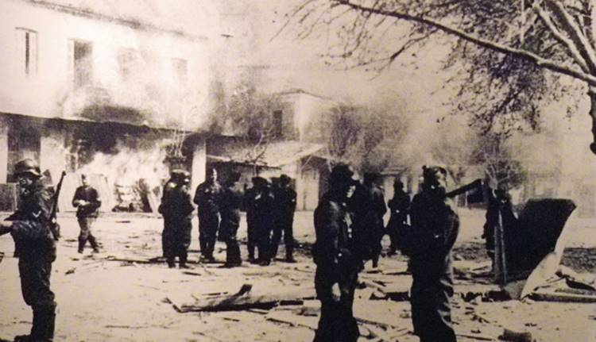
Germans in the burning Distomo
Photo released by Pantelis Karakitsis and made known by Spyros Meletzis. He was found in the pocket of a German prisoner by ELAS. It depicts the Germans in the burning Distomo
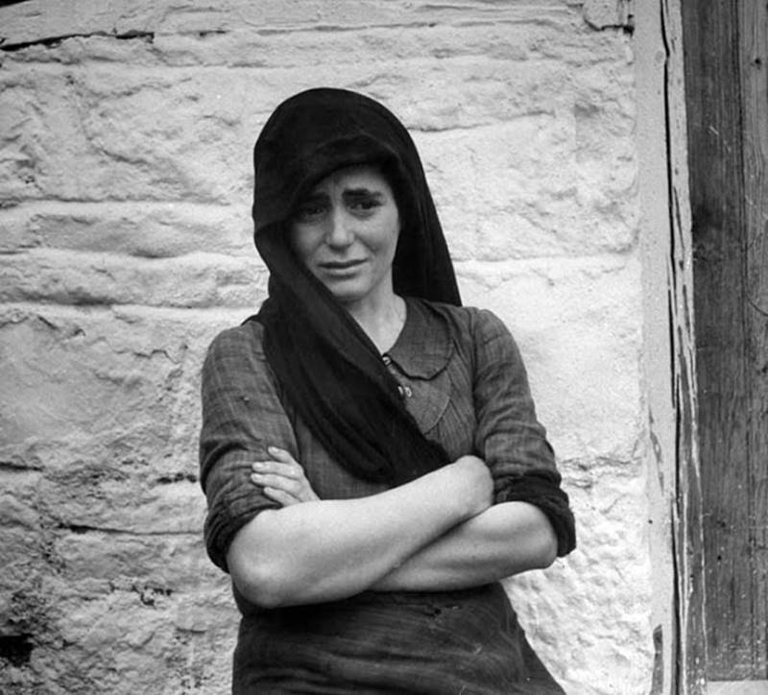
Maria Padiska, Dmitri kessel's photo was first published in Life magazine
On November 29, 1944. The title of the text was "What the Germans did in Greece "
And the caption reads:" Maria Padiska still cries with tears two months after the Germans kill of her mother, in the Greek town of Distomo. "
The massacre in the village of Kalami (June 11, 1944)
The next day, a checkered truck by the German village guard Aliartos was attacked by rebels near Koroneia. Two soldiers were injured and the car was looted.
Shortly after 18:00 a platoon of the 4th Brigade of the I / 7th Regiment was launched by two trucks from Aliartos, with the order to destroy everything alive, on the Aliartou-Livadia public road as the ambush point.
"The cars were not lucky. It was a Sunday and the Greeks were not working in the fields.
Only at the crossroads towards the village of Agios Giorgis did they meet two. George Katis, 45 years old from the village of Agios Georgios and a merchant traveler from the Kokkinia neighborhood of Piraeus. Yannis Pavlidakis. They burst on them, emptying on them their rifles. "
They started at the same time from Livadia, three trucks and two motorcycles and arrived in the small town of Kalami in the evening. Having arrested as hostages, three passers-by.
The infants were not excluded from the subsequent arrests. The three unique male residents were separated from the female children.
And they were executed at the entrance of the village with the hostages.
Following were scenes of unprecedented wilderness:
"Women's children now understand that their end is over and they start crying out loud.
The mothers, with the children in their hands, point them to their killers, and beg them to let their children to leave. And to kill, only them.
Evangelia Slatinopoulou holds her two children tight in her arms. They cried too, without knowing what it expects them.
One of the slayers drags his sword and bayonet one, in his throat. The unexpected sight and the warm blood from the infants make Mother Slatinopoulou outside frenzied , embracing her half-dead children.
Then another slayer, planted a bullet in her head. '
The machine guns covered the howls of the other women. Six men and sixteen women were killed that night and their bodies burned with a kind of powder.

VILLAGE PYRGOI OF EORDEA
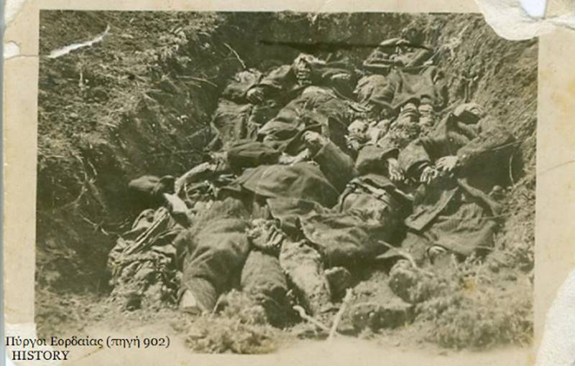
Mass grave of Pyrgoi village residents

April 23, 1944
The Holocaust of Pyrgoi village
On April 24, 1944, Germans, after they surrounded the village, attacked and began killing the residents indiscriminately.

359 men, women and children executed en masse or set on fire in houses or barns

And they grabbed all their belongings.

It is the second largest massacre of civilians in the country after the Kalavryta.

The villages of Mesovouno, Klisoura and Ermakia had already experienced the murderous fury of the conquerors.

In the village of Mesovouno, 157 inhabitants were executed on October 23, 1941.

Another 90, without distinction of age and sex, were slaughtered wildly in April 1944.

On the morning of April 23 the village of Pyrgoi was surrounded by German excerpts.

German conquerors shooted indiscriminately , elderly, old women, young boys and girls, children, little girls and babies

A total of 318 souls.

They burned down the houses and grabbed all their belongings.

'' It was dawning in the village on Sunday, April 23, 1944, of saint Thomas, when the silence was disturbed by the German machine guns . The residents, terrified jumped of their bed, to see what was happening. Many voices were heard everywhere:

"Germans! The Germans are coming! "

It came out of the mouths of terrified residents after the sound from machine guns and the the boom from bombshells.

All terrified, hurried away, taking with them what they could, heading towards the mountain, to be saved.

The Germans from Amyntaio, led by Gestapo officers, entered the Lower neighborhood .

While another group of Germans from Ptolemais had already invaded, at the same time as the first, into the Middle and Upper neighborhood .

What followed it is impossible to be described. It is impossible for the human being to understand, what made the "man" to the man.

The gloomy scenes of Hell fade in comparizon the horror that unfolds in every corner of the village !!!

The middle neighborhood experienced untold calamity.
One hundred and eighty (180) people were burned in flames of the haystacks.

Two hundred meters from away, they tear up Sofia Gesiu's belly, who gave birth the day before. killing first in front of her eyes, her twin babies and her husband .

The Germans searged in the upper slopes of Vermio, finding in the caves, in the holes and in other places, 95 people from the Upper neighborhood who had fled to be saved.

They gathered them under the Great Stone and they coldly, executed them.

Thirty women and children were killed in the Sevastian district, vanishing the Fotiadi family.
Anna Kosmidou tries in vain to protect her five children in her dresses. She herself is rescued from the pile of dead, with nine wounds .

Pericles Melkopoulos had been hiding with his wife and four children in a hideout.

The crying of the younger child betrayed them. The German soldier who found them did not execute them and in a sense let them know that they had to kill the little one in order not to trace them, the other Germans.

The parents refused and the family was saved. In the midst of barbarism and a Christian act, an exception to the rule, fortunately ...

Meanwhile in the Lower neighborhood, the Germans indiscriminately firing whoever was trying to escape, they entered the houses and led people to the site near the Church of Our Lady. Where it also was the cemetery of the neighborhood.

After gathering all the inhabitants, they put them in line and they prepared the machine guns.

There was no way anybody could get away with it. However, some refused to accept death without doing anything. Even if the chances of salvation were limited.

They run into the stream in a hopeless attempt with no avail. The adjoining stream and nearby slopes were filled with dead.

The others in front of the machine guns were waiting the death, being unable to do anything

The inhumane acts of the Germans continued unabated.

They set fire to buildings and burned alive people.

The inhabitants were surrounded from everywhere. Some , who attempted to escape the ravines, fleeing into the mountains, were captured by the Germans and were executed.

Women with superhuman efforts were restrained from shouting. The little children who understood what was happening were crying and were stopping only with the reassurance of the adults.

Surrounded and unable to react, they fell to their fate awaiting death. The crying of infants, endlessly and monotonously, was drowned by their mothers, as they could.
The ruthless Germans, were cutting the belly of pregnant women, were burning the barns with female and children, were raping girls in churches, were shooting anyone in front of them, and were burning everything.

Suddenly and while everything was ready for the completion of the inhuman act, a German motorcyclist brought the order to be transported the survivors to the village of Hania of Ptolemais.

There they kill the teacher Anastasia Siouli, the young Kostas Ververis, after they tortured them horribly and they forced them to dig their graves.

Some of them were released and others were tortured and executed, forced to dig their own tombs with their own hands.

Those who escaped the hands of the German conquerors today cannot forget with sadness those tragic and brutal scenes they lived, from the Germans.
The village surrendered to the flames.

Destroyed ... Ruined ... No stone left on stone. Not a single sample of the Macedonian mansions left in the village of Sachnisi remained.

The affront, however, in its ancient Greek significance, was completed, since our dead were left unburied, prey of the wild beasts.

After more than 10 days, begging the permission from the conqueror, survivors returned to perform the deplorable task of burial of their own.

According to the testimony of Katina Toufexis, who accompanied her father to this effect, "the smell of burnt human flesh was intense in the ruins and burned houses

This image was strongly engraved in the memory of the young girl, who was mentally injured and she never came back again in the village.

Those who were found, many of them unidentified, were buried in mass graves.
The final account of the Holocaust counts 341 dead.
This number is estimated to be even higher.
The complete destruction of the community archives and the failure to return since then to the village of some families , have made it extremely difficult to determine the final number of victims.
KLISOURA OF KASTORIA
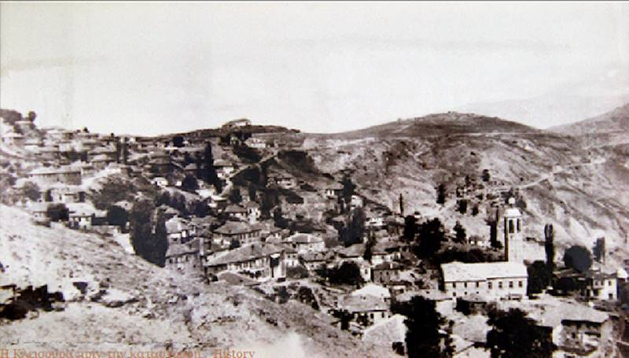

April 5, 1944 ... 280 murdered
A sacrifice of that period of German occupation is also that of the heroic town of Western Macedonia, Klisura. On April 5, 1944
Which is incluted mong the other sacrifices:
At Kalavryta Achaia (December 13, 1943).
At Fanari of Preveza.
At Loutrotopos and Kommenos Arta (16 August 1943),
Mousiotitsa and the Ligniades of Ioannina,
At Distomo Livadia (June 10, 1944).
At Domokos Lamia.
At Karpenisi of Evritania.
At Almiros of Volos.
At Dracia of Magnesia (18 December 1944).
At the Monodendri of Laconia (November 26, 1943).
At Farsala of Larissa.
By Tsaritsanis and Domenikos Elassonas.
At Kerdilia of Serres (October 17, 1941).
At Doxato and Prosotsani of Drama.
At Chortiatis of Thessaloniki.
At Pyrgoi of Eordea (April 24, 1944).
At Kozani and other cities and villages.

Two hundred and eighty (280) innocent people were killed by the Germans in April 1944.

Whole families were exterminateδ .
Pregnant women had been gutted .
Infant mothers fell dead with their children in their arms.
Young girls were slaughtered on the blossom of their age.
Respectful old men who had at all their life defended the ideals of the homeland were burnεd down in their homes.
Not even the priest, who, with the Holy Cross in his hand, begged for mercy and tried to soothe the blooded organs of Hitler's in defense of his flock, did not respect the inhuman beasts of the Germans and they massacred him.

That morning no one could have imagined the evil that was about to happen.

The strategy of "precautionary fire and iron", that is the killing of every potential enemy, in order not to jeopardize "precious German blood," was followed again.

Their target is the village of Klisoura.

They alert the Kastoria and Kozani guards and the Ptolemais SS battalion and instruct them to take retaliatory action against the unsuspecting civilian population.

Who in that day were only of women, children and the elderly. Since the men had made sure to leave for safety in the surrounding mountains and at the Monastery of Our Lady.

Hoping that the German murderous mania would leave the elderly, the women and the children, untouched.

The conquerors did not hesitate to give even fraudulent "guarantees" and to not keep them at the "right" moment.

Behind them followed armoured, the German executioners and arsonists.

The German and with German-military uniform, the Bulgarian Komitas, led by the German commanders of Kastoria Raisel and Hildebrand, and under the direction of the Bulgarian Chief Komitas, after receiving the slogan from a flare , they begun to kill the Greeks , with machineguns, with bayonets and with axe.

And burning the mansions with special powder.

They sowed death without discrimination.

They had gutted pregnant women, they killed with
swords , infant and toddlers,. Girls, falling dead in the fresh grass of the yiards from the hot pencil of machine guns.

Along with the noble housewives, with the respectable old men and the elderly, who were also killed in their famous mansions.
No one has been able to stop the bloodthirsty raiders from the gruesome task of mass slaughter and burning. Not even Pope-George Mitras, who is executed as a neo-martyr with the cross in his hand and is slaughtered .

Within the two-hour period of the command, everything is turned into hell, sowing blood, horror, and death.

And leaving behind two hundred eighty (280) innocent victims. Closing the extensive list of the dead of Operation Maigewitter - Mayan Storm, April 1944.

On the threshold of the two-hour deadline , there were seven women standing on the wall.

But just as the moment the machinegun was preparing to shoot, at that very moment, at about 5 pm, the flare that marked the end of the unspeakable human sacrifice had lit over the craggy Clisura. And the salvation of the seven women happened.

But from their memory and soul will never erase the image of the German with the red from blood raincoat. And also of the dead mother with her child in her arms.

Colonel Slaughter Colonel Karl Schumers (Carl Summers), commander of the 7th Regiment of the 4th USS Armored Division, is described as unruly and rigid.

And the cruelty of his behavior is due to his belief that the Greek population cared for and supported the rebels. And for this reason, they were all complicit in their opposition to the Axis.

Operations against the guerrillas had to offer "terror instead of terror," so that the civilian population would eventually be more afraid of the German forces than from the guerrillas.

The inhumane behavior of Karl Schumers (Carl Summers) has resulted the Third Reich's political representative in the Balkans, Herman Neubacher (Hermann Neubacher), to call the Klisura operation, a bath of blood. And to point angrily, that the atrocities were committed were beyond the orders for retaliation.

But what Noybacher argued was dismissed as unfounded by the Thessaloniki-Aegean Military Commander, thereby encouraging Karl Schumers (Carl Summers) to repeat similar slaughter of civilians shortly afterwards in Distomo.

His fate, however, came to an awkward end . When his car fell on a mine, just outside Arta on August 18, 1944.

In the next few days the inhabitants of the surrounding areas were terrified seeing the beautiful Kleisoura burning. And fire to complement the work of destruction and to illuminate the nights of slavery.

Those who had fled to the woods, returning the next morning found nothing but ruins and dead.

Others embraced the carcasses of their relatives, and others in vain sought them, in the burned bodies.

Clisura had been turned into a huge cemetery. Since the cemetery of the village was not enough to bury the two hundred and eighty (280) victims.

They buried them, in the yards of churches and houses and on the slopes of the mountain.

The terrible Nazi Herod had been fully satisfied of Greek blood and ruins that day. Among them the high school, the bourgeois school, the new elementary school (founded in 1919) and their large library.
